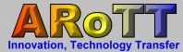 |  | Romanian Association for Technology Transfer and Innovation  Mobility Urban Logistic Cluster  12, Stefan cel Mare street, Craiova, Dolj county, Romania  tel: +40-251-412290; +40-251-412775; Fax: +40-251-418882;  e-mail: office@ipacv.ro; web site: www.arott.ro
From idea, certificate and innovation through technological transfer and services at highly innovative
units with activity based on high added value

The main objective is to support the Oltenia Region to adapt and change their industrial structures to unlock the potential of clusters and entrepreneurship for regional economic development and for addressing societal challenges such as reducing CO2 emissions, optimyse the electric cumsumtion, improving resource efficiency and environmental protection.
The Consortium, according to the philosophy of the “triple helix”, is composed by a company with experience at international level (facilitator and research-innovation), as partner Enterprise Europe Network, a cluster in the field and a National body that coordinate the National Programme Innovation, abilitate for fundings in the field of innovation, research on the benefit of the SMEs.
The aim is in particular to better capitalise on all forms of creativity, new technologies and the transformative power of innovation to shape new globally competitive value chains that may help to foster the development of emerging industries in our region and in Europe.
By supporting the development of more fertile environments in which small and medium-sized enterprises can combine creativity with the use of new technologies, specialy ITC and more resource efficient solutions, new business opportunities may arise that result in smarter and more sustainable growth.

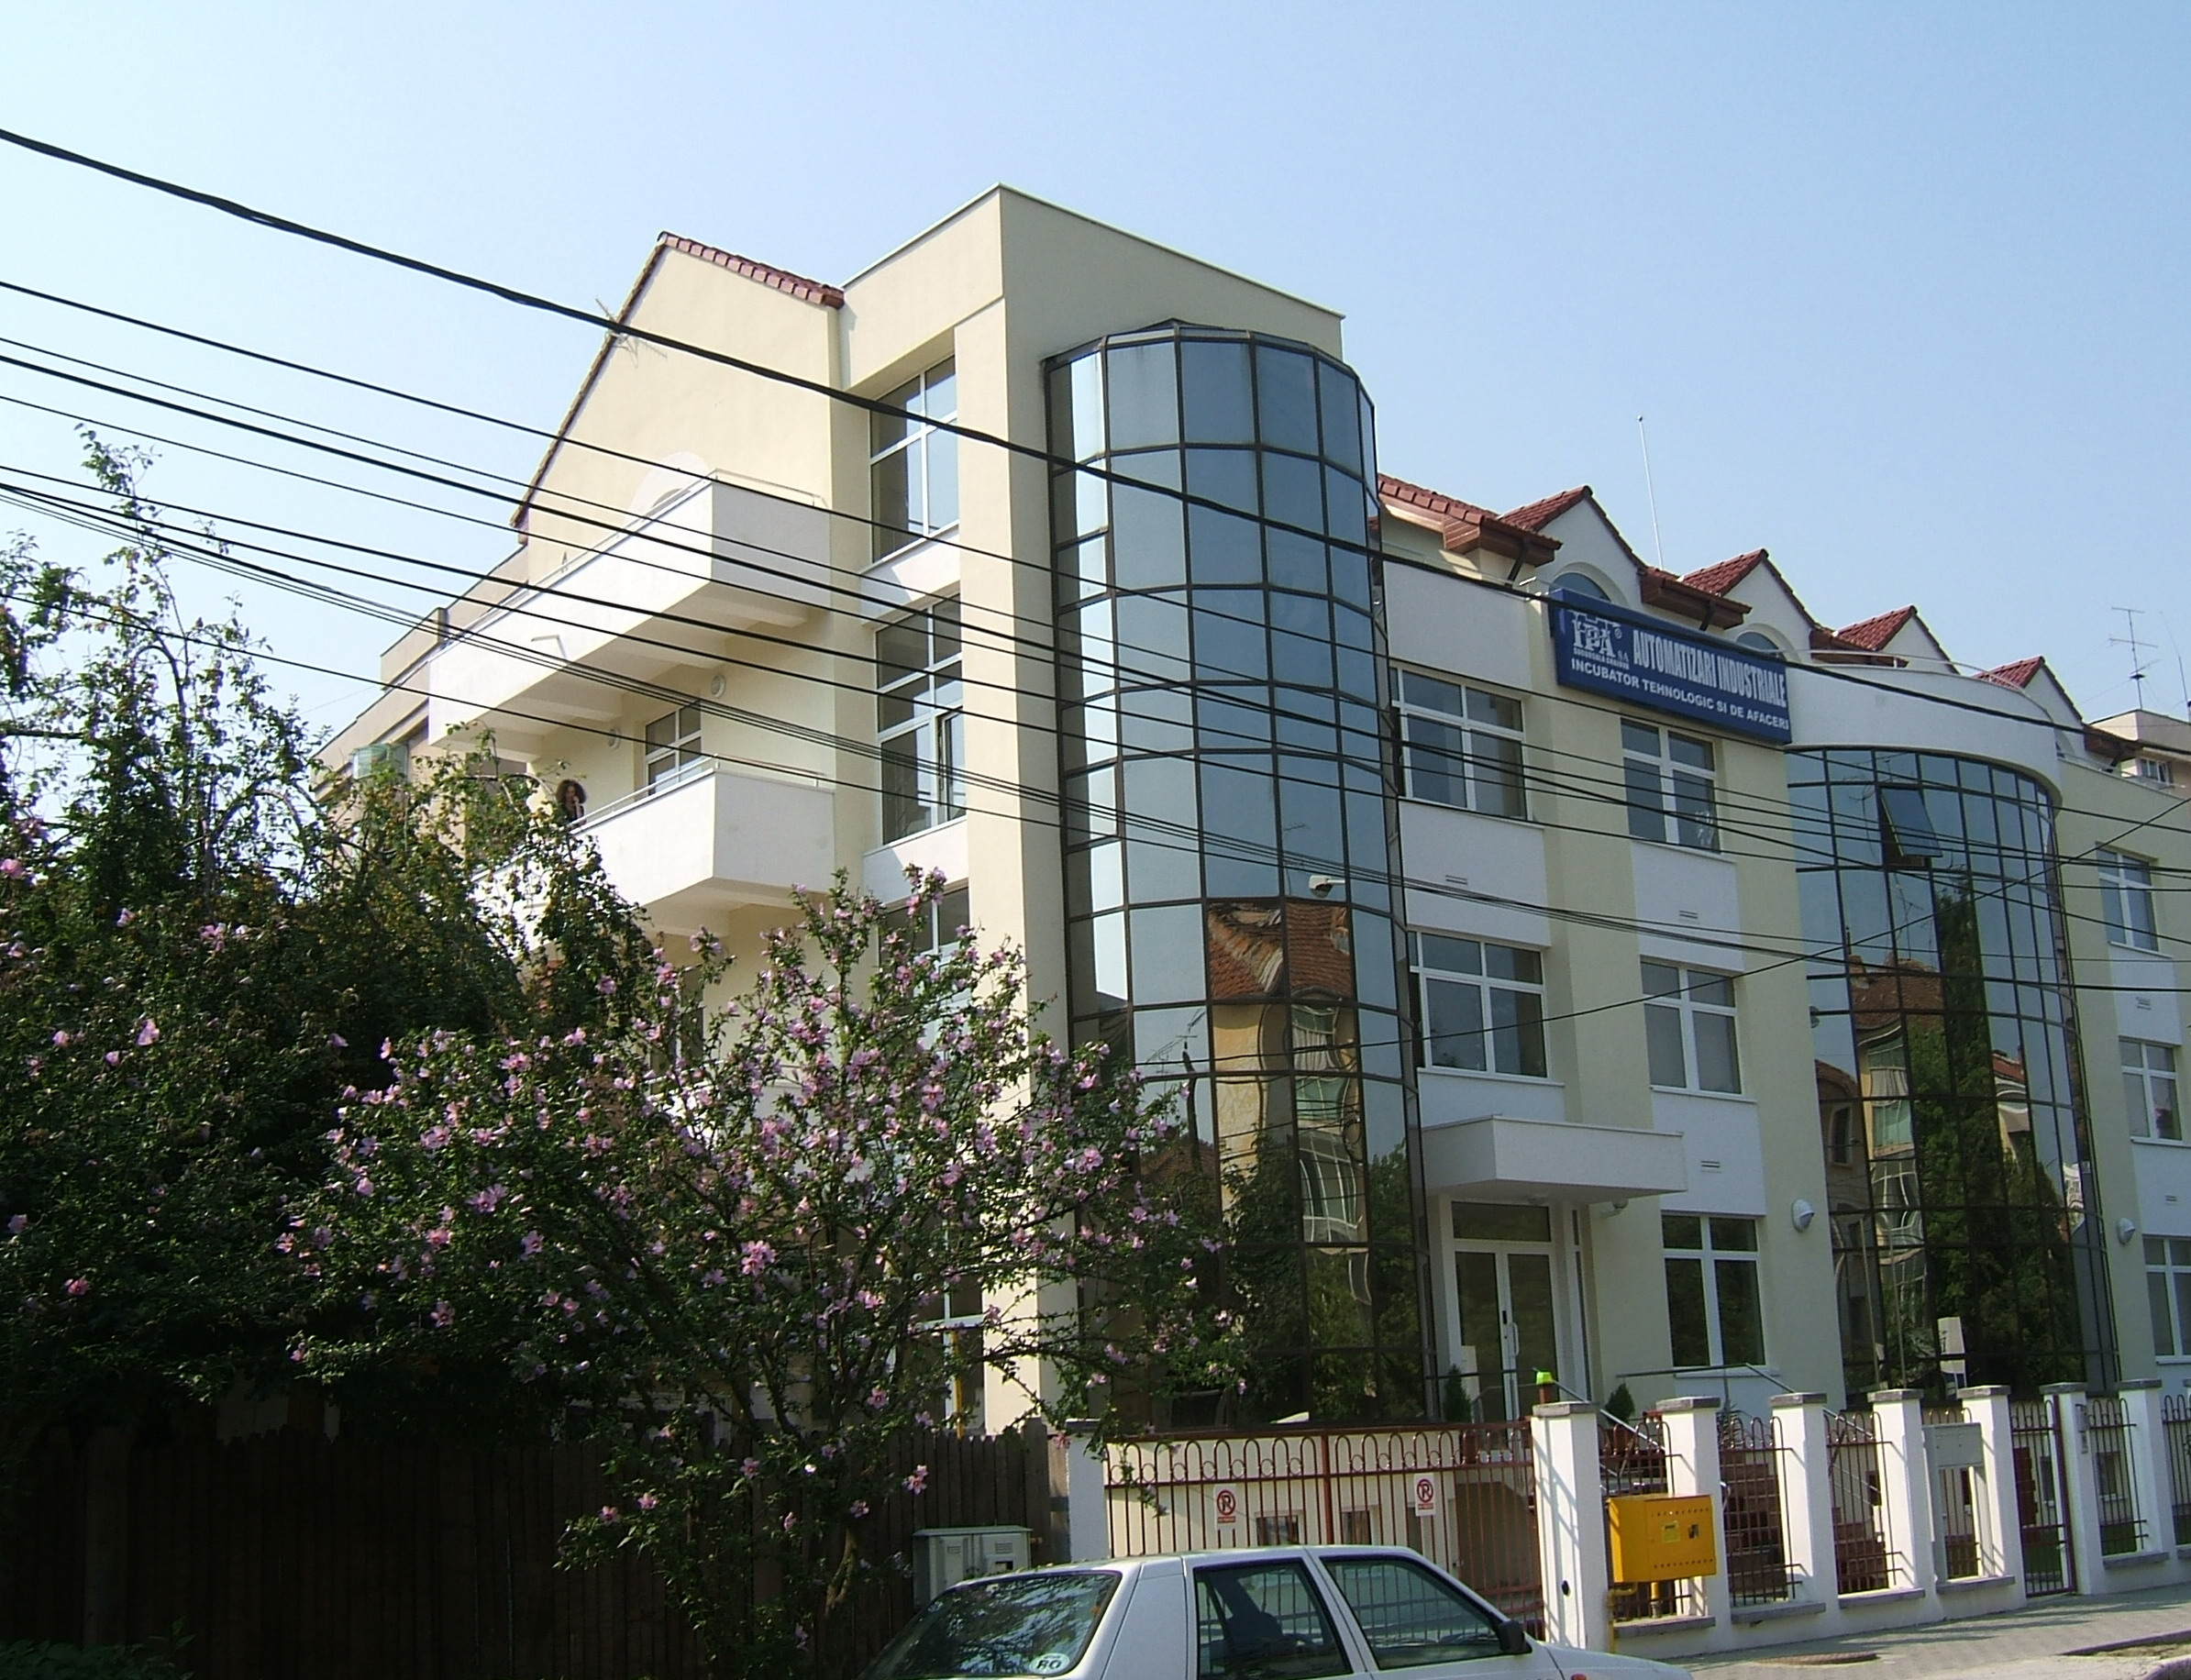 | 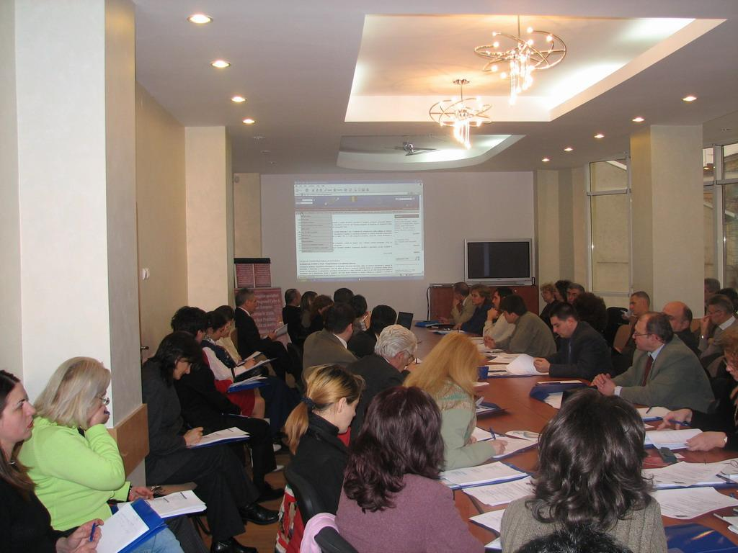 | 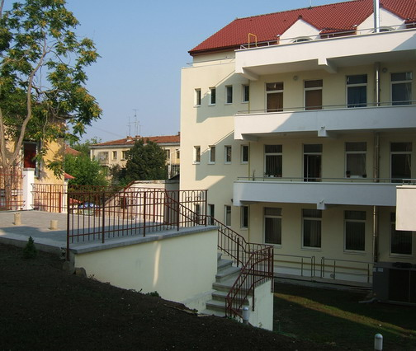
Purpose
- Promoting and protecting business environment of technological transfer entities (incubators, parks, etc)
and innovative business from the Oltenia Region,
- Promote professional interest of members,
- Strengthening professional authority of entities and their social prestige,
- Increased competitively by reinforcing technological and innovation base.

Objective: Increasing number of products and technology offers or used through technological transfer.
Reaching the objective:
- Identify and promote innovative products;
- Promote technological cooperation;
- Access to research results.
- Internationalisation of the cooperation, business, innovation and research partnerships
- To define new lines of research and innovation for the Cluster compliant with the specific technological and territorial specialisations
- To address the research-driven clusters on urban logistics in the Region toward common development areas and to set up operational collaboration on these topics, through networking activities.
- To set up the most appropriate conditions for the full exploitation of the potential results of researches taking into account the “framework conditions” (regulatory, social, economic) which could affect their applicability and effectiveness and suggesting to the relevant stakeholders appropriate solutions.
- To ensure the appropriate spread of knowledge through dissemination actions and stakeholders involvement.
- To support the internationalisation of the Cluster through specific actions
- To define Joint Action Plans (JAP) for the Region, with the active involvement of the Regional Authorities and Agencies, in a coordinated way to plan the future technological innovation activities and to define the reference framework for their funding.
- To mentor the start-up of the research clusters in the most advanced realities by the more assessed ones.
- To monitor the start-up of the activities defined in the JAP.

Ensured services
- Promoting research results for industry and international partners;
- Identify new technology offers and requires;
- Consultance and promoting of new technologies;
- Consultance regarding industrial property, technological transfer trans-national;
- Organize and participate at international meetings, brokerage, market and exhibitions;
- Dissemination; creating partnerships;
- Contractors forming;
- Support for implementing new products or technologies;
- Requirements evaluation and offers for SME’s and their international collaboration abilities;
- Consultancy for certify according to ISO 9001 quality standards.

By "systemic impact" innovations are meant that fundamentally change sectoral boundaries and help improve the
overall efficiency of the eco-system by, for example, better valorising all forms of creativity and promoting
resource efficiency. Such innovations have a profound impact on the way the economy is organised and resources
are allocated and will be highlight by the Cluster.

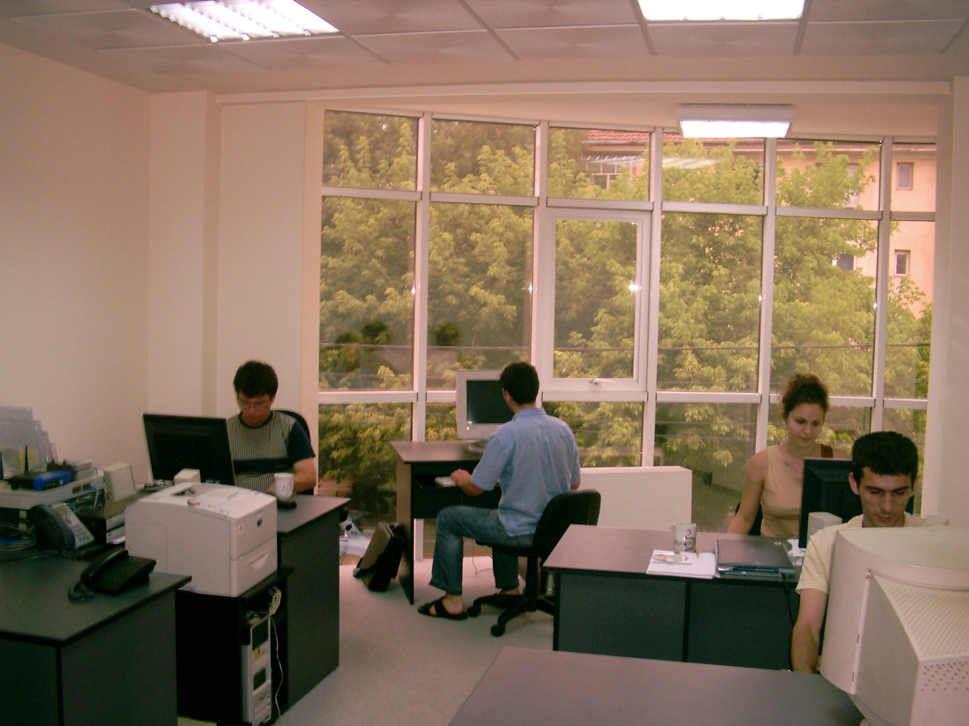 | 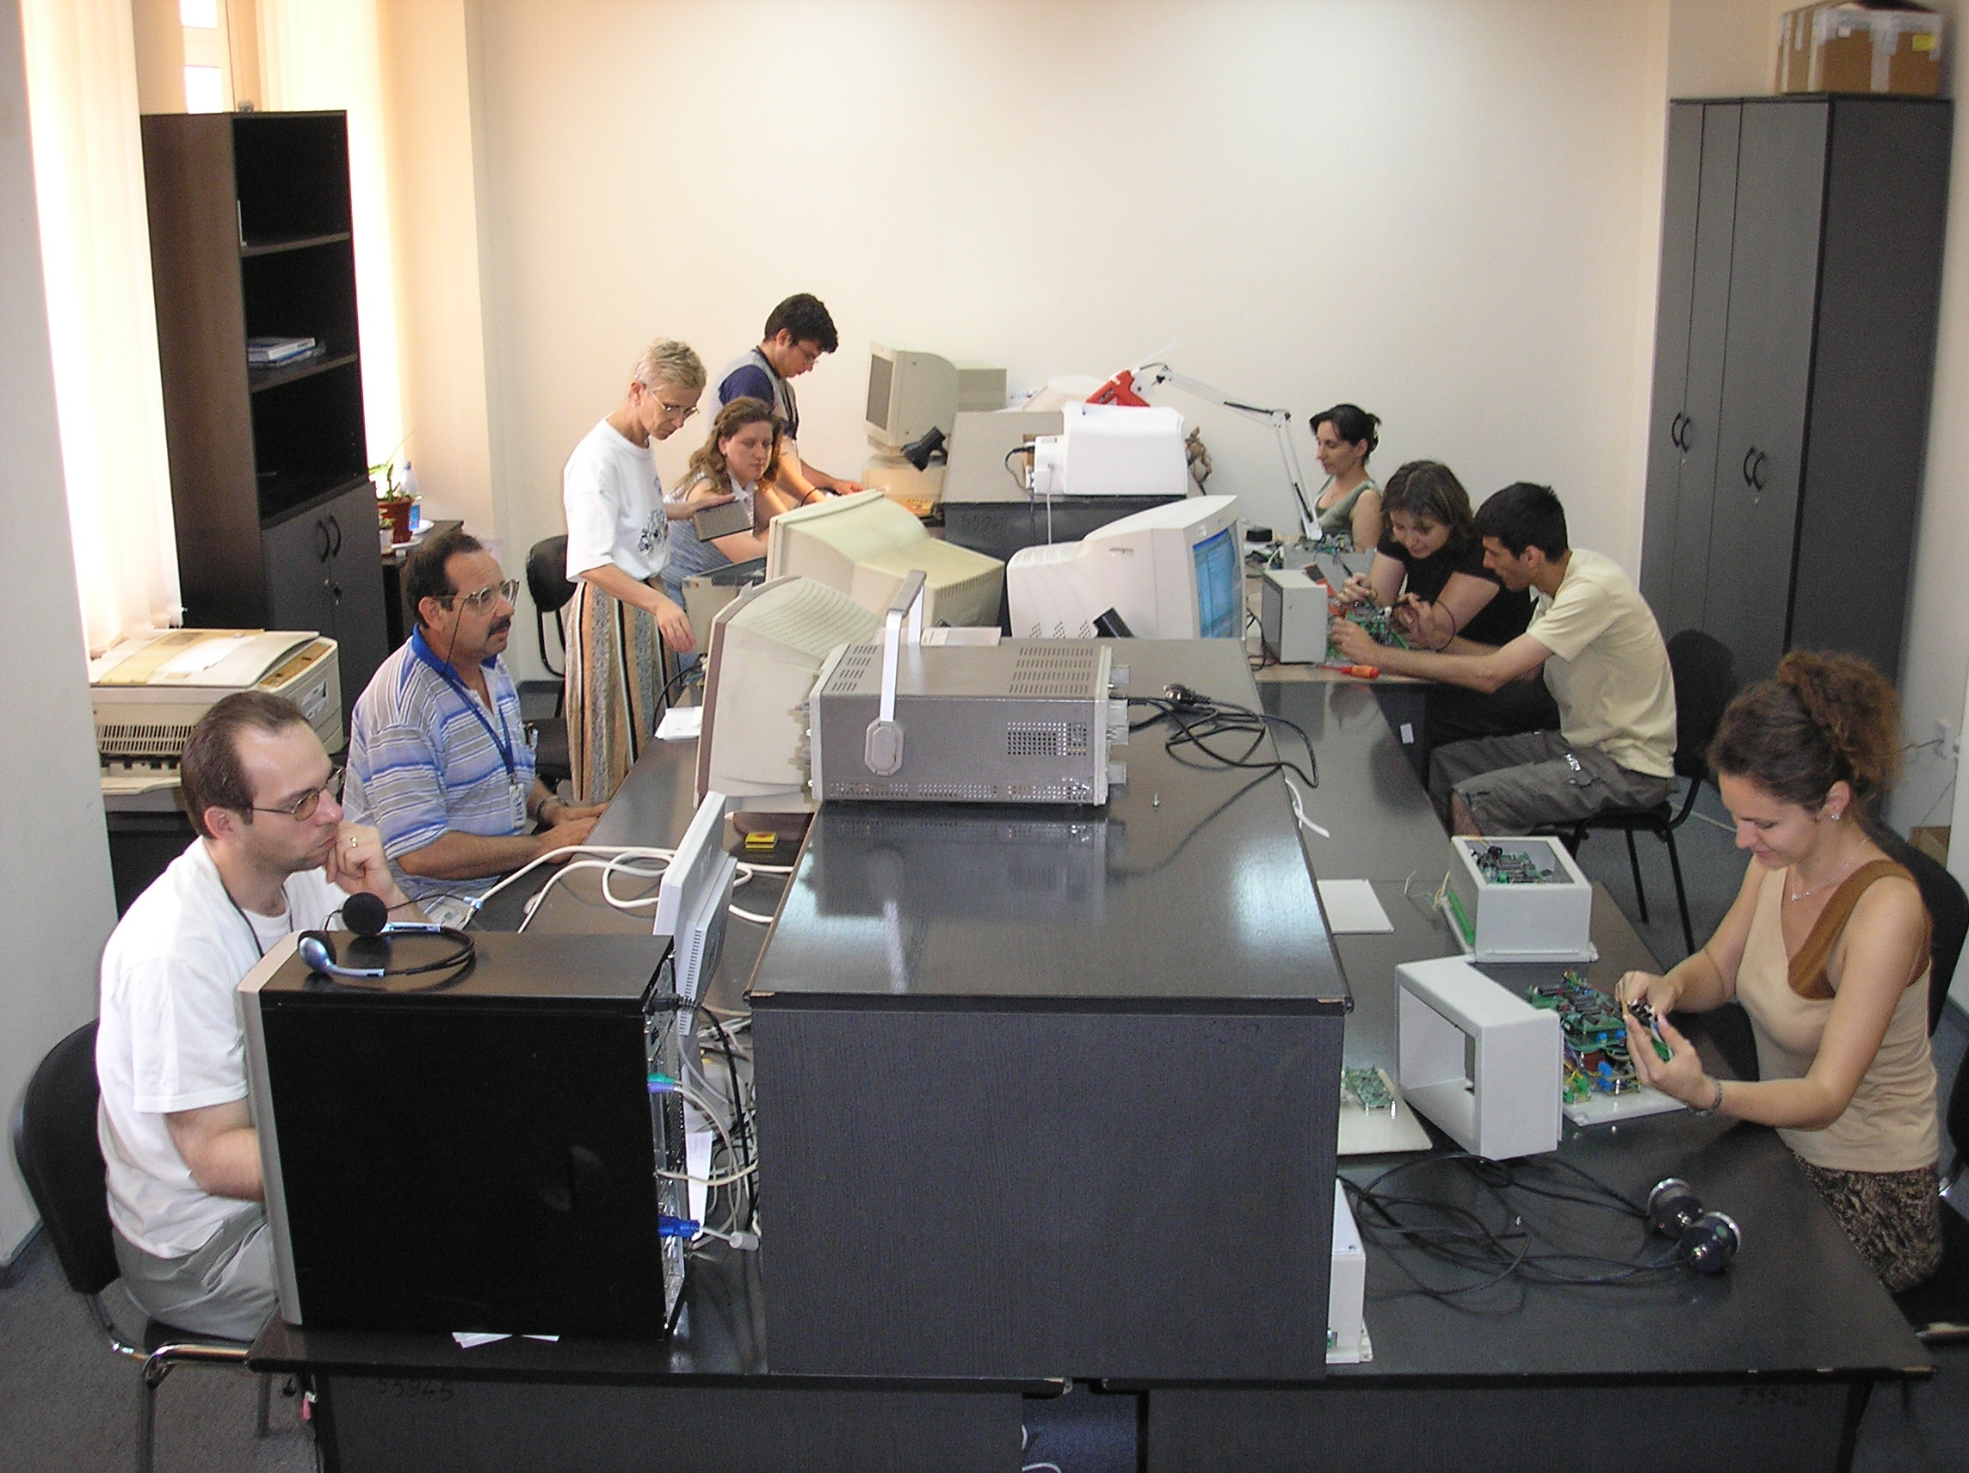 | 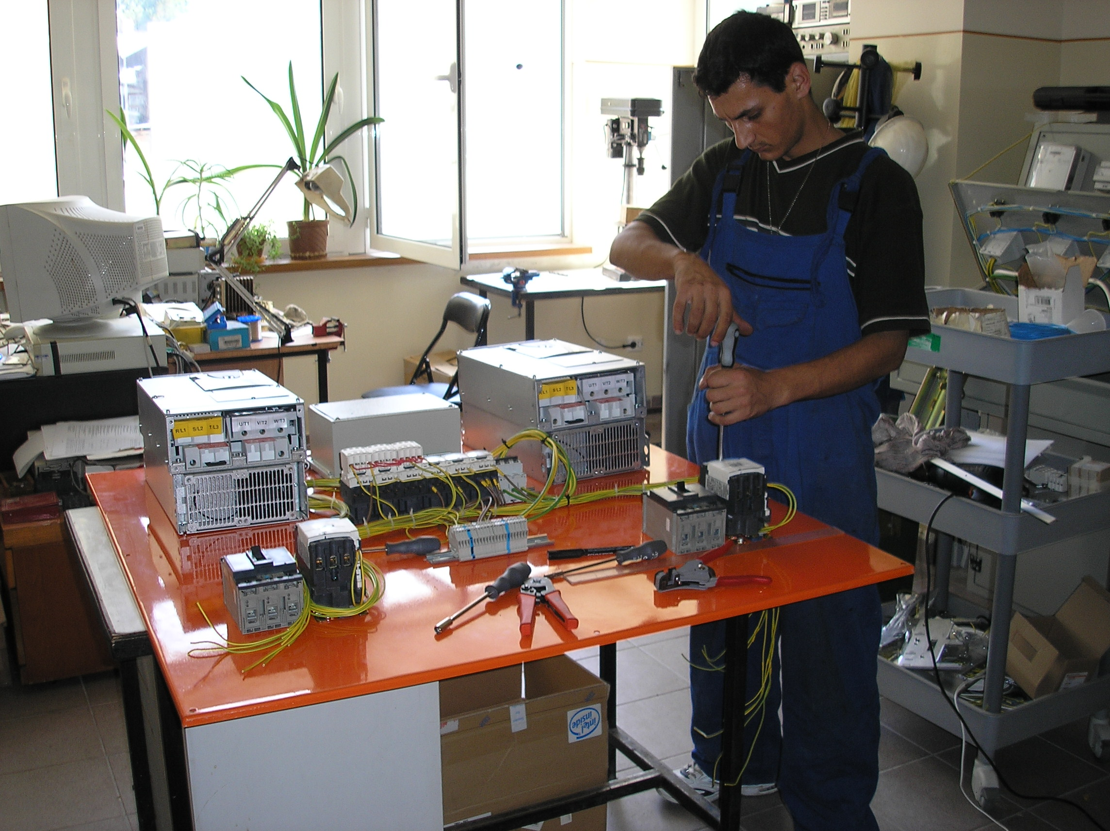

The current economic crisis and on-going global industrial transformations have highlighted the need to
modernise regional industrial structures and build new industrial competences in order to respond to global
competitive and societal challenges. The question that regional policy makers are faced with is how to best
develop regional industrial and SME policies and smart specialisation strategies in order to build a more robust
and resilient industrial base within Oltenia region.
Cluster organisation, the facilitators and other SME intermediaries are the ideal intermediary for creating an
"open space" or an “brokerage platform”, where businesses, knowledge institutions and business support
organisations can meet to search for and explore radically new, cross-sectoral business solutions.
This is the core aim of the Cluster.
Functions "turn-key solutions" covered by the Cluster
- Research and Development
- Engineering, Project Management, System integration, software development
- Monitoring & Control Systems Design,
- IT Support Specialist and Consulting, Technical Support,
- System Integrator; Technological Transfer; Personal Formation,
- Service into guarantee and post-guarantee.
Strategies
- Creating a network in order to stimulate partnerships and developing new promoting innovation strategies;
- Stimulate local communications in order to identify problems, finding solutions & actors for implementation;
- Creating SME’s – Local administration – Research – Innovation – University – Civil society – Industrial
units partnerships in order to develop through innovation;
- Create start-ups, spin-offs and innovative companies base on high added value.
- Information gathering, create partnerships opportunities and business development.
- Increasing number of innovative units based on high added value and number of efficient units based on
innovative technologies.
- New technologies and products could enlarge the market for a significant number of companies providing equipments and solutions for urban logistics.
- The economic competitiveness of the local industrial sector can be increased through a higher level of innovation.
ARoTT- Mobility Urban Logistic Cluster, 12, Stefan cel Mare street, Craiova, Romania, tel/fax +40-251-418882; +40-251-412290; e_mail: office@ipacv.ro

